**Investigating Global Black Money Transactions**

***Course Name:***DSCI 5360 Section 003 - Data Visualization (Fall 2024 1)

***Instructor Name:***Ku, Chih-Hao

***Group Name:***Project Group 11

***Group Members:***

1. Lavanya Manthri (11747205)
2. Akshitha  Veeravelli (11753207)
3. Likhith Killamsetty (11735539)
4. Rakshitha chintalapudi (11814442)
5. Durga veerabadhrananda Dharani Chand Chavali (11753174)

***Submission Date:***December 9, 2024

**Project Proposal:** Investigating Global Black Money Transactions – Patterns, Risks, and Global Implication

1. **Introduction and Background**

**Title:** Exploring Global Black Money Transactions: A Data-Driven Analysis

**Historical Context and Project Aim:** The flow of black money—illicit funds hidden from governments—has troubled global economies for decades. In the late 20th century, the rise of tax havens and offshore banking made it easier for the wealthy and corrupt to conceal vast amounts of money. Scandals like the Panama Papers exposed just how widespread these secret financial networks are, allowing tax evasion and corruption to thrive. Despite global efforts to combat these practices, black money continues to destabilize economies, widening inequality and eroding public trust.

This project aims to uncover patterns in black money flows using advanced data analytics and visualization tools. By focusing on regions, industries, and risk factors, we hope to provide insights that can support the global fight against financial crime and help build a more transparent financial system.

**Motivation:** Our motivation for this project is rooted in a desire to shine a light on a shadowy part of the global economy—black money transactions. These illicit financial flows rob governments of critical resources, fuel corruption, and deepen societal inequalities. As data analysts, we believe that by mapping these hidden networks and uncovering patterns, we can contribute to the global fight against financial crime. This project is about more than just data; it's about using information to promote fairness, transparency, and accountability. By providing clear insights, we hope to empower policymakers, regulators, and organizations to take meaningful action against this persistent threat to global economic health.

1. **Objectives and Goals**

**Learning Objectives:**

1. Improve our ability to analyze and interpret complex financial datasets.
2. Enhance our proficiency in using data visualization tools to communicate impactful insights.
3. Develop a deeper understanding of global financial systems and the role of illicit transactions.

**Project Goals:** The goal of this project is to analyze global black money transactions by identifying key countries and regions involved, understanding which industries are most vulnerable to financial crime, and examining the role of shell companies and tax havens in facilitating illicit transactions. Additionally, we aim to uncover temporal patterns in these flows and explore their connections to global economic and political events. Through this analysis, we seek to provide insights that support efforts to combat financial crime, with further exploration planned to deepen our understanding in subsequent analysis.

**Impact & Target Audience:** This project holds the potential to bring critical insights into the concealed world of global black money transactions, addressing a significant gap in financial transparency. By revealing patterns and risks associated with these illicit flows, the analysis can contribute to more effective strategies for combating financial crime. Its findings aim to support global efforts in reducing economic disparities and restoring trust in financial systems that are often undermined by hidden wealth.

The target audience includes policymakers, government agencies, and international organizations tasked with regulating and controlling financial crimes. Financial institutions, too, will benefit from the insights, using them to strengthen anti-money laundering measures. Ultimately, this project offers data-driven guidance to those who shape the policies and regulations aimed at creating a more transparent and equitable global economy.

**Visualizations:** We plan to create four key visualizations as initial draft to address these questions:

1. ***Global Black Money Flow Heat Map (Map Chart)****:* This map highlights the global distribution of black money transactions, with darker shades indicating higher transaction volumes.
2. ***Transaction Volumes by Industry (Bar Chart)****:* This bar chart shows the total black money transaction volumes by industry, revealing which sectors handle the most illicit funds.
3. ***Relationship Between Shell Companies and Risk Scores (Scatter Plot)****: This* scatter plot illustrates the relationship between the number of shell companies and their money laundering risk scores in tax haven countries.
4. ***Black Money Transactions Over Time (Line Chart)****:* This line chart tracks the month-to-month changes in black money transaction volumes from January 2013 to January 2014 across various countries
5. **Datasets**

**Dataset Description:** The **Global Black Money Transactions Dataset** contains 10,000 records of simulated financial transactions, including detailed information about transaction amounts, countries involved, industries, and associated risk factors. This dataset is designed to represent real-world trends in black money flows and offers a comprehensive foundation for analysis.

Dataset Link: <https://www.kaggle.com/datasets/waqi786/global-black-money-transactions-dataset/data>

**Key Columns in the Dataset:**

1. **Transaction ID:** Unique identifier for each transaction (e.g., TX0000001).
2. **Country:** Country where the transaction occurred (e.g., USA, China).
3. **Amount (USD):** Transaction amount in US dollars (e.g., 150,000.00).
4. **Transaction Type:** Type of transaction (e.g., Offshore Transfer, Property Purchase).
5. **Date of Transaction:** Date and time of the transaction (e.g., 2022-03-15 14:32:00).
6. **Person Involved:** Identifier or name of the person/entity involved (e.g., Person_1234).
7. **Industry:** Industry associated with the transaction (e.g., Real Estate, Finance).
8. **Destination Country:** Country where the money was sent (e.g., Switzerland).
9. **Reported by Authority:** Whether the transaction was reported to authorities (e.g., True/False).
10. **Source of Money:** Origin of the money (e.g., Legal, Illegal).
11. **Money Laundering Risk Score:** Risk score indicating the likelihood of money laundering (1-10) (e.g., 8).
12. **Shell Companies Involved:** Number of shell companies used in the transaction (e.g., 3).
13. **Financial Institution:** Bank or financial institution involved in the transaction (e.g., Bank_567).
14. **Tax Haven Country:** Country where the money was transferred to a tax haven (e.g., Cayman Islands).

**Data Provenance:** This dataset was created for educational purposes and simulates real-world black money transactions. It offers a rich source of data for analyzing illicit financial flows and understanding the key risk factors involved in global black money activities.

**Data Limitations:** The Global Black Money Transactions Dataset is simulated, which means it may not perfectly capture the complexities and nuances of real-world black money flows, limiting generalizability. The dataset might lack granular details, such as the motivations behind specific transactions or the influence of local regulations. Additionally, geographical and temporal coverage may exclude critical regions or events relevant to illicit financial activities. The reliance on simulated data introduces potential discrepancies in accurately representing risk scores and transaction behaviors.

**Related Publications:**

1. Global Financial Integrity (GFI) Reports  
   *Title*: *Illicit Financial Flows from Developing Countries: 2004-2013*  
   *Summary*: This report provides data on how black money moves across borders, focusing on developing countries.

Link : <https://gfintegrity.org/>

1. FATF (Financial Action Task Force) Publications  
   *Title*: *Money Laundering and Terrorist Financing: Vulnerabilities of Legal Professionals*  
   *Summary*: This paper discusses how legal loopholes and shell companies are used to hide black money.

Link : <https://www.fatf-gafi.org/>

**Dataset Scope :** The **Global Black Money Transactions Dataset** contains **10,000 records** of simulated financial transactions from various countries and industries. It provides insight into illicit money flows globally.

1. **Geographical Coverage**: Multiple countries, including major financial centers and tax havens.
2. **Time Period**: Simulates transactions over the past decade, allowing analysis of trends over time.
3. **Industries**: Covers key industries like real estate, finance, and construction.
4. **Variables**: Includes details like transaction amounts, countries involved, risk scores, and the use of shell companies.
5. **Questions and Visualizations**

**1) Title**: "**Global Black Money Flow Heat Map -** Volume of Black Money Transactions by Country"

**Proposed Question**: "How does the distribution of black money vary geographically, and which regions exhibit the highest intensity of financial activity?”

**Purpose**: To identify regions with high financial activity related to black money for further analysis of underlying factors, patterns, and possible interventions. This map visualization provides a clear understanding of geographical hotspots where black money activity is most concentrated.  
**Scope**: This study will create a heat map to illustrate the volume and pathways of black money transactions between countries. It will focus on identifying and comparing transaction volumes in different regions, highlighting the significant areas of activity. By examining these flows, the study aims to uncover patterns and anomalies in the black money movement, enabling a deeper understanding of international financial misconduct and informing strategies for global financial governance. Visualization: Global Heat Map showing the flow of black money across countries.

**Filters:**

* **Transaction Type:** Offshore transfers**.**

**Color grading:** The color intensity will darken based on the sum of the transaction amount, with higher amounts shown in darker shades.

**X-Axis and Y-Axis:**

* Coordinates (longitude and latitude) for global positioning on the map.

**Key Insights:**

* **High Concentration in Key Regions:** Brazil, China, and the USA are marked with intense green shades, indicating these countries have the highest volumes of offshore black money transactions. This suggests significant laundering activities in these regions, warranting targeted regulatory actions.
* **Emerging Risk in Russia and India:** Russia and India display lighter green shades compared to Brazil and China, reflecting moderate transaction volumes. These countries may represent growing areas of concern for black money flows.
* **Switzerland and UAE as Notable Tax Havens:** Known for their financial privacy laws, Switzerland and the UAE appear on the map, highlighting their role in attracting offshore transfers. This reinforces their reputation as tax havens where black money transactions might go undetected.
* **Geographical Spread Across Continents:** The presence of countries from South America, North America, Asia, and Europe shows that black money transactions are a global issue. This widespread distribution calls for coordinated international efforts to address financial misconduct.
* **Absence of African Countries Except South Africa:** Only South Africa appears in Africa, suggesting either lower transaction volumes in other African nations or potentially less data availability. This could imply regional disparities in financial transparency or data reporting practices.

**2) Title**: “Top Industries Involved in Black Money Transactions - Sectors Prone to financial crime”.

**Proposed Question**: "What industries are most frequently involved in black money transactions, and what characteristics make these sectors vulnerable to financial crime?"

**Purpose:** The purpose of this research is to conduct a comprehensive analysis of industries that are most susceptible to black money transactions and understand the underlying characteristics that make these sectors vulnerable to financial crime. This study aims to provide valuable insights for regulators, compliance officers, and business leaders by identifying key risk factors and vulnerabilities within various business sectors, ultimately contributing to the development of more effective preventive measures and compliance frameworks. Through this analysis, stakeholders will be better equipped to develop targeted strategies, strengthen industry-specific compliance measures, and enhance their understanding of financial crime vulnerabilities in their respective sectors.

**Scope:** The research will examine high-risk sectors globally, focusing on their structural vulnerabilities, patterns of illicit financial activities, and relevant case studies. The study will investigate cross-border transactions and regulatory frameworks while concentrating on legitimate industries potentially misused for illicit purposes. The analysis will be based on documented cases and verified data, examining key factors that enable black money transactions across different jurisdictions.

**Visualization Type:**

* Bar Chart  
  **Description:** A bar chart displaying transaction volumes by industry, highlighting sectors with the highest volumes of black money transactions.

**Filters:**

* **Industry**: Allows selection of specific industries to focus the analysis.
* **Amount Range (USD)**: Filters transaction volume ranges for refined insights.

**X-Axis (Industry)**: Lists various industries involved in black money transactions.

**Y-Axis (Transaction Volume (Billion USD))**: Represents the total volume of black money transactions per industry.

**Color grading:** The color intensity will darken based on the sum of the transaction amount, with higher amounts shown in darker shades.

**Key Insights**

* + **Finance Leads in Transaction Volume**:  
    The Finance sector has the highest transaction volume at $3.74 billion, likely due to its large cash flow and offshore investments. This makes it a prime target for black money activities and money laundering.
  + **Construction and Arms Trade are High-Risk Sectors**:  
    Construction and Arms Trade follow closely with $3.71 billion and $3.60 billion, respectively. These sectors are prone to financial crime due to their involvement in large transactions and often complex supply chains.
  + **Luxury Goods Show Significant Illicit Activity**:  
    With $3.60 billion in transactions, the Luxury Goods industry is vulnerable to black money, as high-value items make it easy to conceal large amounts of illicit funds. This indicates the need for tighter regulation in luxury markets.
  + **Real Estate as a Money Laundering Avenue**:  
    Real Estate, with $3.58 billion in transactions, is commonly used for money laundering, as property purchases offer a way to legitimize illicit funds. This sector's high volume underscores the importance of transparency in property transactions. **Casinos and Oil & Gas Show Lower Volumes but High Risk**:  
    Although Casinos and Oil & Gas have lower volumes ($3.42 billion and $3.38 billion), they still represent high-risk sectors. Casinos are attractive for laundering due to cash transactions, while Oil & Gas involves complex international dealings.

**3) Title**: “**High-Risk Transactions by Country, Reporting Status, and Industry**”

**Proposed Question**: “What are the countries with the highest money laundering risks in specific industries, and how do risk levels vary across countries and industries?”

**Purpose**: This analysis aims to identify high-risk countries for money laundering activities within specific industries. It also seeks to provide insights into the distribution of risk levels (high, medium, and low) by examining the average risk scores across nations and industries. The study will help prioritize regulatory focus and anti-money laundering efforts globally.  
**Scope**: The analysis focuses on countries with varying risk levels for money laundering, categorized by industry risk. The data includes high, medium, and low-risk classifications, with average risk scores for each country. The study aims to explore regional variations in money laundering risks and industries where these risks are most prominent.

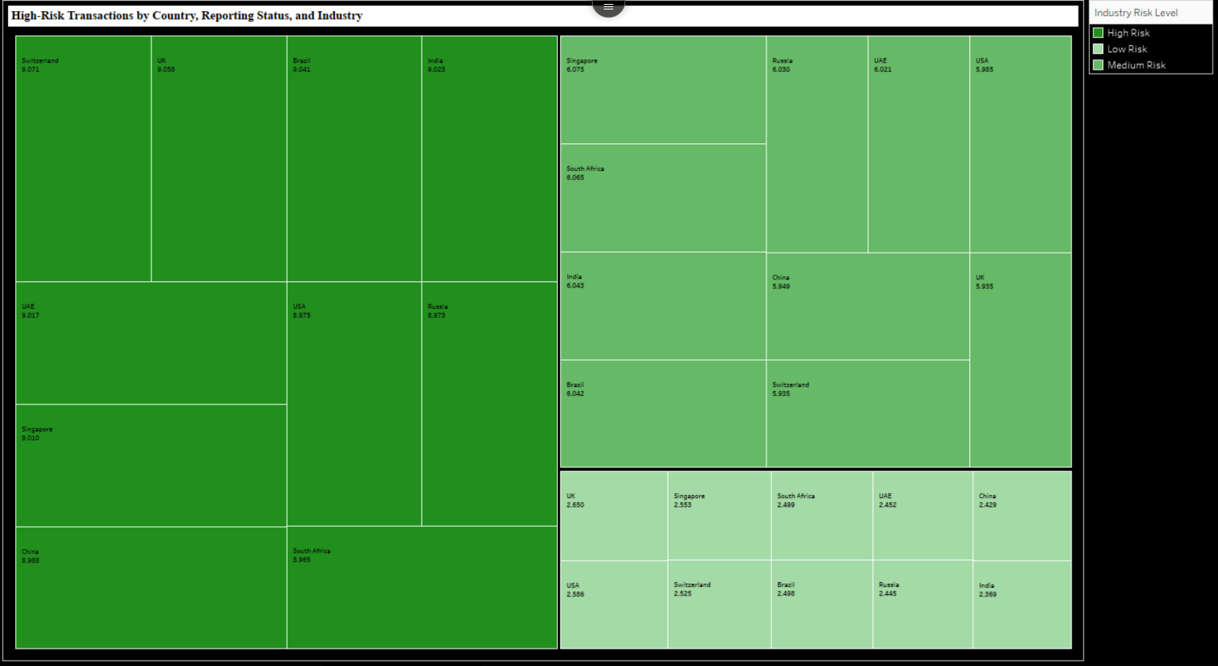

**Calculated field:**

* **Industry Risk Level:**

IF [Money Laundering Risk Score] > 7 THEN "High Risk"

ELSEIF [Money Laundering Risk Score] > 4 THEN "Medium Risk"

ELSE "Low Risk"

END

**Key Insights:**

* **Top High-Risk Countries:** Switzerland, Brazil, India, and Singapore have the highest average risk scores (all exceeding 9), indicating they are key hotspots for money laundering activities across industries.
* **Medium-Risk Countries:** Countries like Russia, UAE, and China have moderate risk levels, with scores ranging from approximately 6 to 6.5, suggesting significant but not critical vulnerabilities.
* **Low-Risk Countries:** Countries like the UK, Singapore (in certain industries), and the USA show much lower risk scores, with averages below 3, implying effective mitigation mechanisms or less exposure to high-risk industries.
* **Industry Variability:** The same country may exhibit varying risk levels across industries. For example, Switzerland appears in both high and medium-risk categories, indicating industry-specific vulnerabilities.
* **Focus for Interventions:** Regions with consistently high risk across multiple industries, such as Switzerland and Brazil, require immediate and targeted regulatory actions to curb money laundering activities effectively.

**4) Title**: “Black Money Transactions Over Time: January 2013 - January 2014”

**Proposed Question**: " What temporal patterns can be observed in black money transactions, and do these patterns align with global economic or political events?”

**Purpose**: This research aims to investigate the correlation between shell companies, risk-scoring patterns, and transactions involving tax havens. The study seeks to understand how shell companies operate within tax havens and their impact on financial risk assessment, providing valuable insights for financial institutions, regulators, and compliance professionals to enhance their monitoring and risk management strategies.

**Scope**: The study will examine the operational patterns of shell companies in tax havens, analyzing transaction flows, risk-scoring methodologies, and their interconnections. The research will focus on documented cases and data from recognized tax havens, investigating how shell companies influence risk scores and financial transactions. This includes analysis of common transaction patterns, regulatory reporting, and risk assessment frameworks used to identify suspicious activities.

**Filters:**

* **Country**: Filter by specific countries involved in transactions.

**X-Axis**

* + **Month of Date of Transaction**: Represents each month within the specified date range.

**Y-Axis**

* + **Amount (USD)**: Transaction volume in billions of USD.

**Key Insights:**

* + **Peak Transactions at the Beginning and Mid-Year:** The highest transaction volumes occur in January and May 2013, both reaching $0.22 billion. This pattern suggests increased black money movement during these months, potentially influenced by external events.
  + **Significant Drop in July 2013:** The transaction volume sharply declines to $0.13 billion in July 2013, marking the lowest point of the year. This drop may indicate seasonal or regulatory influences that temporarily reduced illicit financial flows.
  + **Fluctuating Transaction Volumes Throughout 2013**: Transaction volumes vary widely, with several rises and falls across the year, reflecting inconsistent black money flow patterns. This volatility highlights the need for continuous monitoring to capture irregular spikes or dips.
  + **Moderate Stability in Late 2013:** From September to November 2013, transaction volumes stabilize around $0.17-$0.19 billion, showing a brief period of consistency. This suggests a possible normalization of black money activities during these months.
  + **Abrupt Decline at the Start of 2014:** In January 2014, transactions plummet to $0.12 billion, the lowest recorded in the displayed period. This sudden drop could signal regulatory interventions or economic changes affecting black money flow.

5) **Title:** Risk Levels by Transaction Type and Tax Heaven Country

**Proposed question**: Which tax haven countries are associated with the highest money laundering risk scores for specific transaction types, and how does the risk level vary across different types of transactions (e.g., Cash Withdrawals, Offshore Transfers)?

**Purpose**: This heat map is designed to identify variations in money laundering risk across different transaction types and tax haven countries. By highlighting average risk scores, it enables quick identification of high-risk areas, assisting in pinpointing specific transaction types and countries that may require increased monitoring or regulatory focus. This visualization supports informed decision-making for prioritizing compliance and investigative resources.

**Scope:** This heat map identifies high-risk combinations of transaction types and tax haven countries by visualizing average money laundering risk scores. It supports targeted regulatory actions by highlighting areas that may require enhanced monitoring and enforcement.

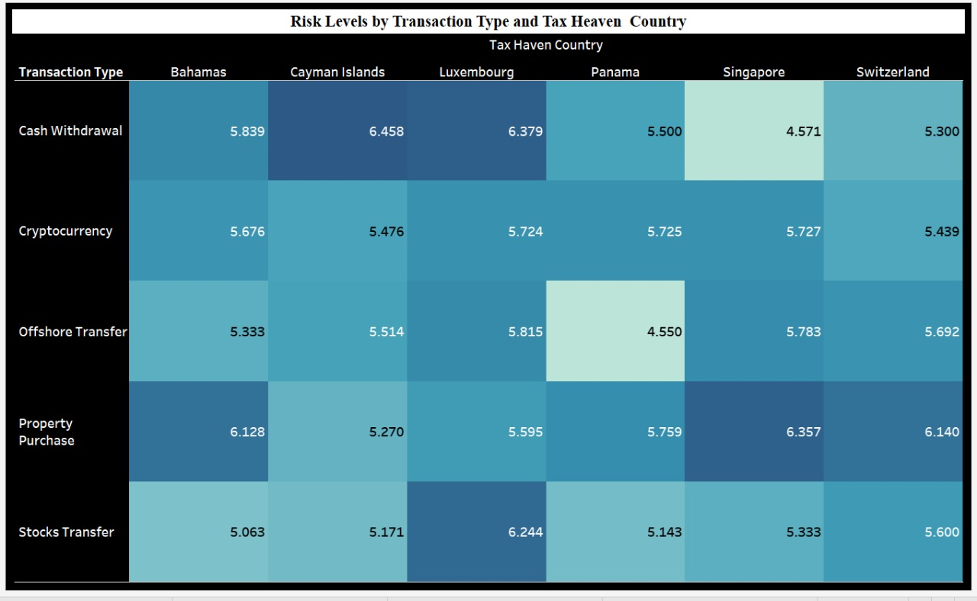

**X-axis (Tax Haven Country: Column):** Represents various tax haven countries involved in transactions, allowing for comparison of risk levels across these locations.

**Y-axis (Transaction Type: Rows):** Displays different transaction types, enabling analysis of the associated money laundering risk for each category.

**Filters:**

* **Transaction Type**: Filters the data to show only selected types of transactions, allowing for a focused analysis on specific transaction categories.
* **Tax Haven Country**: Limits the view to specific tax haven countries, enabling targeted examination of risk scores across chosen regions.

**Color coding:** In this heat map, **color** shows the **Average Money Laundering Risk Score** for each **Transaction Type** and **Tax Haven Country** combination. Darker colors indicate higher risk (around 5.7871), while lighter colors show lower risk (around 4.9965). This color range helps quickly spot high-risk areas, with dark cells highlighting where more attention may be needed.

**Insights:**

* **Risk Concentration by Transaction Type**: The heat map reveals which transaction types, such as **Cash Withdrawal** or **Offshore Transfer**, are associated with higher average money laundering risk scores across tax haven countries.
* **High-Risk Tax Haven Countries**: Darker shades in certain countries, like **Switzerland** or **Cayman Islands**, highlight regions with elevated risk levels, indicating areas that may require closer regulatory attention.
* **Comparative Analysis of Countries**: By comparing the color intensity across countries, this visualization allows for quick identification of tax havens that frequently appear in high-risk transactions.
* **Transaction Type Vulnerability**: The visualization shows which types of transactions are more vulnerable to high-risk activities, helping organizations prioritize monitoring efforts based on transaction types.
* **Targeted Filtering**: Filters enable focused insights by country or transaction type, allowing for a more detailed examination of specific risk factors in individual tax haven countries.

6) **Title:** Laundered Transaction Amount by Tax Haven

**Proposed question:** How do laundered transaction amounts vary across major tax haven countries, and which countries exhibit the highest concentration of these activities?

**Purpose:** The purpose of this bubble chart is to provide a clear and comparative representation of laundered transaction amounts across tax haven countries. By visualizing the data through bubble sizes, it identifies the countries with the largest financial flows associated with laundering activities, aiding in understanding the scale and distribution of illicit transactions.

**Scope:** This analysis focuses on identifying and comparing tax haven countries based on their laundered transaction amounts. By using bubble sizes to represent transaction volumes, it highlights countries like Switzerland, Cayman Islands, and others as key players in global laundering networks. The visualization serves as a tool for stakeholders, including policymakers and regulatory bodies, to identify critical regions for intervention and formulate strategies to mitigate illicit financial activities. It also supports trend analysis across countries, allowing for targeted actions in combating financial crimes.

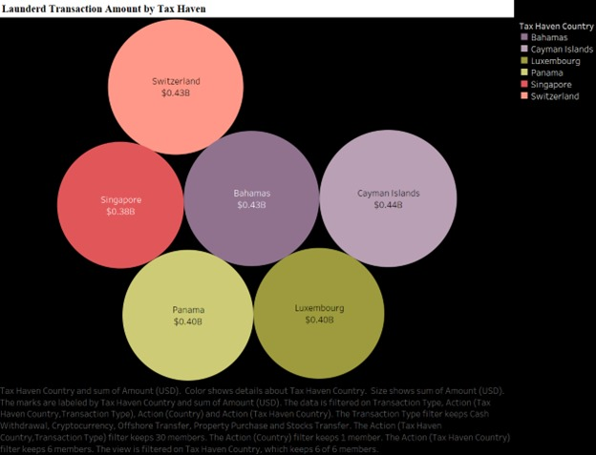

**Marks:**

* **Circle (Mark Type)**: The data points are represented using circles, with size corresponding to the transaction amounts.
* **Color**: Different colors are assigned to each tax haven country to differentiate them visually.
* **Size**: The size of the bubbles is proportional to the sum of transaction amounts (e.g., $0.38B, $0.43B).
* **Label**: Displays the name of the tax haven country and the corresponding laundered amount on the bubbles.
* **Detail**: Adds granularity to each bubble, linking the data to its specific country and amount.
* **Tooltip**: Provides additional information (e.g., transaction type, exact amount) when hovering over the bubbles.

**Filters**:

* **Transaction Type**: Allows filtering data by the type of transaction being analyzed (e.g., Cash Withdrawal, Offshore Transfers, etc.)
* **Tax Haven Country**: Filters the data to show only specific tax haven countries such as Bahamas, Cayman Islands, Luxembourg, Panama, Singapore, and Switzerland.

**Insights:**

* **Switzerland as a Dominant Player**: Switzerland has the largest bubble, representing the highest laundered transaction amount ($0.43B). This reinforces its historical role as a major hub for financial activities, including laundering-related transactions.
* **Cluster of High Transaction Countries**: Cayman Islands, Bahamas, and Luxembourg have similarly sized bubbles ($0.43B–$0.44B), indicating a significant concentration of laundered funds in these regions. These tax havens likely serve as key facilitators in global money laundering networks.
* **Singapore's Significant Role**: Despite being smaller in size compared to Switzerland, Singapore has a notable bubble size ($0.38B), reflecting its prominence as a financial hub and a destination for laundering activities in the Asia-Pacific region.
* **Panama's Contribution**: Panama's bubble size ($0.40B) underscores its relevance as a tax haven, maintaining its reputation as a significant player in facilitating illicit financial flows.
* **Relative Comparisons**: While all displayed countries are prominent tax havens, Switzerland and Cayman Islands emerge as the top two destinations in terms of laundered transaction amounts, requiring higher regulatory scrutiny.

**7) Title: Financial Institutions Involved in High-Risk Transactions by Country**

**Proposed question:** Which countries have the highest involvement of financial institutions in high-risk transactions, and how does the average money laundering risk score vary across these tax heaven countries?

**Purpose:** The graph visualizes the involvement of financial institutions in high-risk transactions across various tax heaven countries, emphasizing their role in potential money laundering activities. It combines two key metrics: the count of institutions engaged in these transactions and the percentage of the total money laundering risk score attributed to each country. This visualization aids in identifying nations with significant institutional involvement in high-risk financial behaviors, supporting regulatory and monitoring efforts.

**Scope:** This analysis focuses on tax heaven countries with notable engagement in money laundering risks, highlighting the comparative scale of institutional participation and associated risk percentages. It provides insights for financial authorities to target oversight and compliance measures effectively.

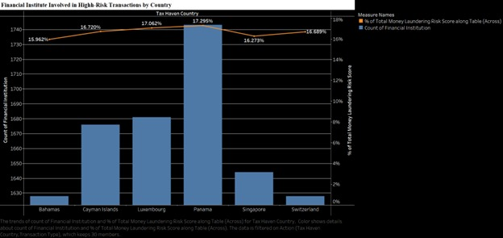

**X-axis (Tax Heaven Country: Column):** Represents different nations involved in high-risk transactions

**Y-axis:** It has two parts: the **Count of Financial Institutions** (left axis) represented by blue bars and the **% of Total Money Laundering Risk Score** (right axis) represented by an orange line.

**Color Coding:**

* The **blue bars** represent the **Count of Financial Institutions** involved in high-risk transactions for each country. The height of the bars reflects the number of institutions, with taller bars indicating a higher count.
* The **orange line** represents the **% of Total Money Laundering Risk Score** associated with each country. The line shows the risk percentage as a secondary measure, providing an additional layer of insight into the financial risk each country poses relative to money laundering activities.

**Insights:**

* **High Participation Across Tax Heaven Countries**: The count of financial institutions involved in high-risk transactions is fairly consistent across the listed countries, with each bar representing a similar range close to 1000 institutions. This indicates a widespread issue across multiple regions.
* **Percentage of Total Money Laundering Risk**: The orange line indicates the **% of Total Money Laundering Risk Score** for each country, which hovers around 10%. This suggests that while the number of institutions is high, the risk percentage remains somewhat uniform across countries, highlighting a standardized risk distribution.
  + **Dual Axis Comparison**: The use of a dual axis enhances understanding by allowing the comparison of two metrics—**Count of Financial Institutions** (left y-axis) and **% of Money Laundering Risk Score** (right y-axis). This setup visually separates the count and risk percentage, making it easier to assess both metrics independently.
  + **Synchronized Axes**: The synchronized y-axes ensure that the scales are aligned, making it straightforward to see how the count of institutions correlates with the percentage of money laundering risk. This alignment highlights that countries with a high institution count also have a proportionate share of the risk score, maintaining a balanced risk-to-participation ratio.
  + **Top and Bottom Risk Scorers**: The countries at the peak risk percentage are Switzerland (10.1694%) and China (10.3503%), while South Africa and the USA have comparatively lower risk percentages, at around 9.67%. This subtle variance indicates some fluctuation in risk exposure, despite the similar count of financial institutions.

8) **Title**: Monthly Trends of High-Value Black Money Transactions by Tax Haven Country

**Purposed Question:** How do transaction amounts fluctuate over time for different transaction types, and are there any noticeable trends or patterns?

**Purpose:** The purpose of this analysis is to understand the monthly trends in high-value black money transactions across tax haven countries, segmented by transaction types such as Cash Withdrawal, Cryptocurrency, Offshore Transfer, Property Purchase, and Stocks Transfer. By studying these trends, the analysis seeks to identify fluctuations, patterns, and anomalies in transaction volumes over time to provide insights into potential drivers of illicit financial flows.  
**Scope:** The scope of this analysis is to examine monthly fluctuations in high-value black money transactions across tax haven countries from January 2013 to January 2014, segmented by transaction types such as Cash Withdrawal, Cryptocurrency, Offshore Transfer, Property Purchase, and Stocks Transfer. It aims to identify patterns, trends, and anomalies in transaction volumes over time and compare the magnitude of different transaction types. The findings will help inform risk assessments and provide actionable insights for monitoring and preventing illicit financial activities.

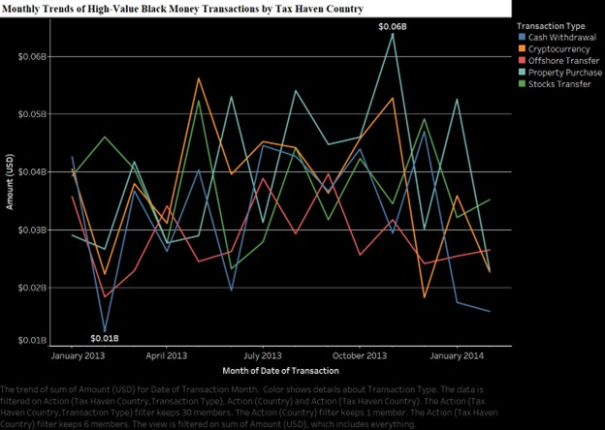

**X-axis(Column)**: Represents the **Month-Year of Date of Transaction**, showing the timeline of high-value transactions from January 2013 to early 2014.

**Y-axis(Rows)**: Indicates the **Amount (USD)**, displaying the transaction volume in millions of USD for each tax haven country over time.

**Filters:**

* **SUM(Amount (USD)):** The filter restricts data based on the total transaction amount in USD.
* **Transaction Type:**Filters data by different transaction types such as Cash Withdrawal, Cryptocurrency, Offshore Transfer, Property Purchase, and Stocks Transfer.

**Color Coding:**

* **Color (Transaction Type)**: Each transaction type (e.g., Cash Withdrawal, Offshore Transfer) is represented by a distinct color to differentiate trends and patterns visually in the line chart.

**Insights:**

* **Fluctuating Transaction Trends Across Countries:** The graph shows monthly variability in black money transactions, likely influenced by external factors like regulations or economic shifts, emphasizing the need for constant monitoring.
* **High Transaction Peaks in Mid-2013**: A significant spike in mid-2013 suggests an increase in high-value transactions, possibly due to favorable conditions, warranting further investigation into potential causes.
* **Significant Decline Towards Early 2014:** Early 2014 shows a marked decline in transactions, potentially reflecting regulatory interventions, highlighting how policy changes impact laundering activities.
* **Country-Specific Patterns and Consistency:** Countries like Switzerland and Singapore exhibit relatively consistent transaction levels, suggesting stable high-value activity in these regions.
* **Panama and Cayman Islands as Major Transaction Hubs:** Panama and Cayman Islands frequently appear as top transaction hubs, likely due to favorable secrecy laws, indicating high-risk areas for anti-money laundering focus.

**Dashboards**

**Dashboard-1: Global Black Money Transactions**

**Purposed Question:** Which countries and industries are involved in high-risk black money transactions, and how do these transactions change over time?

**Purpose**: The purpose of this dashboard is to aid in understanding and combating black money transactions by providing actionable insights into their geographic and sectoral distribution. It aims to highlight the key industries at risk and their potential role in facilitating financial crime, assisting in risk assessment and mitigation strategies. Furthermore, the time-series visualization allows stakeholders to detect seasonal or event-driven patterns in illicit financial activities. By offering a clear picture of the flow of black money, the dashboard supports regulatory and law enforcement agencies in designing targeted interventions. Ultimately, it helps promote transparency and integrity within the global economic framework by identifying areas of concern and guiding policy development.

**Scope**: This dashboard provides a comprehensive overview of global black money flows, highlighting the countries and industries most implicated in illicit financial transactions. By visualizing the distribution and volume of these transactions, it identifies geographical hotspots such as China, the USA, and Switzerland, where black money activities are prominent. It also focuses on high-risk industries like construction, arms trade, luxury goods, real estate, casinos, and oil and gas, showcasing their susceptibility to financial crimes. Additionally, the dashboard tracks temporal trends, offering insights into how transaction volumes fluctuate over time. This serves as a valuable tool for policymakers, investigators, and financial institutions to address vulnerabilities in the global financial system.

**Overview of the Dashboard**:

This dashboard offers a comprehensive analysis of global black money transactions, emphasizing high-risk regions, transaction trends over time, and industries susceptible to financial misconduct

* **Global Black Money Flow Heat Map**: The heat map visually represents the volume of black money transactions across different countries. Key regions, including China, India, the USA, and Brazil, are highlighted due to their higher transaction volumes, which suggest significant financial risk. The varying shades on the map correspond to transaction intensity, with darker shades indicating countries where black money flows are more concentrated. This visualization allows stakeholders to quickly identify and prioritize regions requiring closer regulatory scrutiny based on transaction frequency and risk levels.
* **Black Money Transactions Over Time**: This line chart tracks monthly black money transaction volumes from January 2013 to January 2014, providing insight into temporal fluctuations. Peaks and troughs in transaction volumes may align with particular economic, regulatory, or geopolitical events, suggesting that external factors can influence the movement of illicit funds. This step helps in understanding how transaction patterns vary over time, enabling analysts to correlate spikes in activity with global events that might prompt an increase in high-risk transactions
* **Top Industries Involved in Black Money Transactions**. This bar chart identifies industries most susceptible to black money transactions, with sectors like Finance, Construction, Arms Trade, and Luxury Goods showing the highest transaction volumes. These industries often present unique vulnerabilities due to high cash flow, limited oversight, or ease of cross-border transactions. By highlighting these sectors, the chart guides regulatory bodies toward areas where enhanced compliance and monitoring efforts could have the most significant impact in curbing illicit financial flows.
* **Risk Score Analysis**: This component assesses the average risk scores associated with transactions across different countries and industries. By evaluating the risk levels assigned to these transactions, regulators can pinpoint regions and sectors with consistently high money laundering risk scores. This insight supports the prioritization of resources, allowing for more focused monitoring and enforcement where the potential for financial crime is greatest. It also provides a framework for tracking the effectiveness of anti-money laundering measures over time.
* **Monthly Trend Comparison Across Regions**: This analysis compares transaction trends across multiple countries on a month-by-month basis, helping to identify patterns or anomalies in high-value black money flows. By examining these trends regionally, analysts can detect similarities or outliers, such as a sudden spike in transactions in one country compared to others. This comparative view enables better understanding of regional dynamics and can signal the need for targeted investigations or policy adjustments in specific areas.
* **Policy Recommendation Insights**: Based on transaction patterns, risk scores, and industry involvement, this step generates actionable insights for policy recommendations. By identifying the countries, industries, and transaction types most associated with high-risk activities, the dashboard equips stakeholders with the information needed to shape effective regulatory policies. This guidance supports proactive measures, enabling governments and organizations to address vulnerabilities in the global financial system and strengthen their defenses against illicit money flows.

**Dashboard 2: Analyzing Black Money Flow and Risk in Tax Havens**

**Purposed Question:** What patterns and trends can be observed in black money transactions over time and across tax haven countries?

**Purpose**: The purpose of this dashboard is to empower decision-makers to detect vulnerabilities and develop strategies to mitigate the flow of illicit funds in tax haven countries. It aims to reveal transaction types and regions with the highest money laundering risks, enabling targeted interventions. By showcasing temporal trends, it supports efforts to pinpoint periods of heightened activity, which may coincide with global events or policy changes. The focus on financial institutions provides clarity on systemic risks, facilitating improved compliance and oversight mechanisms. Ultimately, the dashboard serves as a vital tool for regulators, policymakers, and anti-money laundering (AML) professionals to combat financial crimes effectively.

**Scope**: This dashboard focuses on identifying and analyzing black money transactions within major tax haven countries such as the Bahamas, Cayman Islands, Luxembourg, Panama, Singapore, and Switzerland. By categorizing risk levels by transaction type, it provides insights into the highest-risk activities, such as property purchases and offshore transfers. Additionally, the dashboard highlights monthly trends in high-value transactions, offering a time-series analysis to detect patterns and anomalies. The inclusion of financial institution involvement across countries helps identify the role of institutional frameworks in enabling these transactions. It provides a comprehensive view to support stakeholders in understanding regional and temporal dynamics in black money flows.

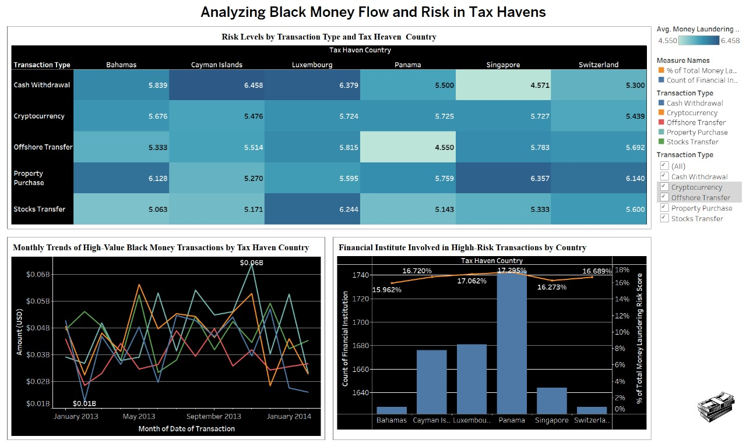

**Overview of the Dashboard:**

This dashboard provides a detailed analysis of black money flow and risk levels in tax havens, with a focus on transaction types, risk scores, and trends across countries:

* **Assessing Risk by Transaction Type and Tax Haven**: The heat map categorizes various transaction types, such as Cash Withdrawals and Cryptocurrency, by their risk levels across tax havens like the Bahamas and Switzerland. Darker colors signal higher money laundering risk scores, helping identify countries and transaction types that are particularly susceptible to financial crimes and warrant closer oversight.
* **Financial Institutions Linked to High-Risk Transactions by Country**: This bar and line chart shows the involvement of financial institutions in high-risk transactions across different countries, with China, South Africa, and Switzerland exhibiting both high institution counts and significant shares of the total risk score. This data directs regulatory bodies to prioritize monitoring efforts in these regions due to their higher association with illicit activities.
* **Monthly Patterns in High-Value Black Money Transactions by Tax Haven**: The line chart tracks monthly trends in high-value black money transactions within tax havens from January 2013 to early 2014. By analyzing these fluctuations, authorities can identify months with heightened activity, potentially linked to external factors. This insight helps detect emerging trends and aligns monitoring efforts with periods of increased risk.
* **Transaction Type and Risk Profile Relationships**: The dashboard draws attention to the link between specific transaction types and their risk profiles across tax havens. By identifying which types of transactions carry higher risks in each jurisdiction, this data enables a more targeted regulatory response tailored to the financial activities that pose the most substantial laundering threats in each region.
* **Role of Shell Companies in Laundering Processes**: The bubble chart highlights the role of shell companies in facilitating laundering, with darker colors showing where these entities are most prevalent. Tax havens like the Cayman Islands and Switzerland show significant shell company involvement, especially in transactions like Offshore Transfers, underscoring the need for stricter transparency measures in jurisdictions heavily used for concealing illicit financial flows.
* **Comparative Analysis of Tax Haven Regulations and Laundering Activities**:  
  By comparing risk levels and transaction volumes across tax havens, the dashboard highlights regulatory discrepancies that may influence laundering activity. Countries with laxer regulations show higher involvement in high-risk transactions, suggesting a need for international regulatory alignment to prevent exploitation of these differences for illicit financial activities.
* **Insights for Policy Development and Strategic Enforcement**:  
  Using data-driven insights from transaction patterns, risk profiles, and country-specific trends, the dashboard provides a basis for strategic policy recommendations. This enables regulators to craft targeted anti-money laundering (AML) measures that address specific risks in each jurisdiction, supporting a more effective and proactive approach to reducing global financial crime.

**Unique Insights:**

We have also created stories apart from the dashboards and worksheet to share the unique insights gained from the data

**Story-1**

**Purposed question:** Which country has the highest black money in property purchase transaction type and which industry plays major role and what are the monthly transactions of it

**Purpose**

The purpose of this study is to understand **China's dominance** in black money transactions within the property sector, revealing the extent of its financial involvement and systemic risks. By analyzing industry roles, the study identifies sectors like construction and finance that act as key facilitators in laundering money through property deals. Furthermore, tracking monthly transaction patterns helps detect fluctuations influenced by seasonal, regulatory, or economic factors. These findings provide a foundation for targeted policy-making and enhanced anti-money laundering strategies focused on high-risk regions like China.

**Scope**

This analysis focuses on identifying the country with the highest black money transaction volume in the **property purchase** category, with particular emphasis on **China** as the highlighted region. The study examines the role of industries in facilitating illicit property transactions, emphasizing those with the highest financial involvement. Additionally, it explores the monthly trends of these transactions from **January 2013 to January 2014** to uncover patterns, anomalies, and potential external drivers. Insights from this analysis are crucial for pinpointing systemic vulnerabilities and guiding policy interventions in high-risk regions.

**Overview of the Story**

* **China as the Leader in Property Purchases**: China emerges as the country with the highest transaction volume in the property purchase category, indicating its significant involvement in black money flows. The heatmap highlights its financial prominence, suggesting that its property market may serve as a major avenue for laundering illicit funds.
* **Industry Analysis**: The construction industry leads with a transaction volume of **$0.45 billion**, followed closely by the finance and real estate sectors. These industries are critical enablers in China's black money network, leveraging high cash flow and complex financial transactions to mask illicit activity.
* **Monthly Transaction Patterns**: A notable peak in monthly transactions is observed in **May 2013 and December 2013**, with volumes reaching **$0.25 billion**. This reflects potential external influences, such as policy changes or market fluctuations, on black money activities in China.
* **Geographical Insights**: While China leads in property purchases, the analysis also highlights regional interconnections between tax havens and China's transactions. This underscores the importance of addressing global financial networks alongside regional markets.
* **Policy and Regulatory Implications**: The study highlights the urgent need for stricter regulations in China's property market to curb black money flows. It also emphasizes enhancing global financial transparency, especially in industries like construction, which play a pivotal role in enabling these activities.

**Story-2**

**Purposed question:** How do monthly transaction trends and the role of financial institutions in the Cayman Islands contribute to its high money laundering risk, particularly in Cash Withdrawals?

**Purpose:** The purpose of this study is to analyze how the Cayman Islands' financial ecosystem and transaction trends contribute to its status as a high-risk jurisdiction for money laundering. By examining the role of financial institutions—which are fully engaged in high-risk transactions—and fluctuations in monthly transaction volumes, this research seeks to identify structural vulnerabilities. The findings aim to assist policymakers and financial authorities in designing targeted anti-money laundering measures specific to cash withdrawals and high-risk institutional practices.

**Scope:** This analysis focuses on the Cayman Islands, which exhibits the highest money laundering risk in cash withdrawals with a score of 6.458, as highlighted in the heatmap. The study investigates the monthly trends in high-value transactions and the pivotal role of financial institutions in sustaining these risks. By understanding these patterns, the study aims to uncover the systemic factors that make the Cayman Islands a prominent hub for illicit financial activities. These insights provide a foundation for mitigating risks through improved regulatory oversight and institutional reforms.

**Overview of the Story**

* **Cayman Islands Leading in Cash Withdrawal Risks**: The Cayman Islands ranks highest in money laundering risks for cash withdrawals with a score of **6.458**, significantly surpassing other tax havens. This indicates systemic vulnerabilities in its financial institutions' handling of cash-based transactions.
* **Role of Financial Institutions**: The graph highlights the **306 financial institutions** involved in high-risk transactions in the Cayman Islands. These institutions represent **100%** of their operations being high-risk, suggesting a lack of effective regulatory checks on these entities.
* **Monthly Transaction Trends**: A peak in high-value transactions is observed in **June 2013**, reaching **$0.018 billion**, with sharp fluctuations across the year. These trends point to external factors, such as policy changes or market shifts, influencing transaction behaviors.
* **Comparative Insights**: Compared to other jurisdictions, the Cayman Islands consistently exhibits higher risks, particularly in cash withdrawals. Its role as a global tax haven amplifies its involvement in financial crimes, emphasizing the need for stricter international regulatory cooperation.
* **Policy Implications**: The study underscores the necessity for enhanced monitoring and tighter regulations on financial institutions operating in the Cayman Islands. Specific focus on cash withdrawals and their correlation with institutional practices can help reduce the risk of money laundering.

**Concepts covered in this course:**

* + - **Effective Storytelling with Data:**   
      The project employs narratives and visualizations to create engaging stories, such as "China Property Purchase" and "Cayman Islands Cash Withdrawal," tying data insights to real-world implications. This ensures that the audience connects with the data and understands its significance.
    - **Clarity and Simplicity:**  
      Visual elements like heatmaps, bar charts, and scatter plots are designed to be intuitive and accessible. They present complex data in a straightforward way, emphasizing specific insights like geographical black money flows or high-risk industries.
    - **Interactive Dashboards:**  
      Filters and interactivity are central to the project’s dashboards, allowing users to explore data by transaction type, country, and industry. This aligns with Tableau’s principle of user-centric design, providing a customizable and dynamic experience.
    - **Visual Hierarchy and Design:**  
      Strategic use of colors, sizes, and gradients creates a clear visual hierarchy. For instance, darker shades in heatmaps signify higher transaction volumes, while larger bubble sizes in scatter plots represent greater laundering amounts.
    - **Insightful Comparisons:**  
      The project facilitates comparisons across regions, industries, and timeframes, helping identify patterns and outliers. This approach highlights disparities, such as the roles of tax havens versus emerging economies in black money flows.
    - **Temporal Trends Analysis:**  
      The inclusion of line charts tracking black money transactions over time demonstrates an understanding of Tableau’s capabilities in temporal analysis. These visuals correlate transaction trends with external events, enhancing interpretability.
    - **Purpose-Driven Visuals**:  
      Every visualization is tied to a research question or actionable insight, ensuring that the design serves a specific analytical purpose. This is evident in visuals that identify high-risk industries or track monthly transaction variations.
    - **Focus on Data Enrichment:**  
      The dataset is enriched with additional dimensions, such as shell companies, laundering risk scores, and financial institutions, enabling a multi-faceted analysis. This aligns with Tableau’s principle of maximizing the value of available data.
    - **Polished Presentation:**  
      The dashboards and stories reflect attention to detail and design principles, with well-aligned elements, readable fonts, and a professional finish. These aspects enhance the credibility and impact of the visualizations.
    - **Actionable Insights and Recommendations:**Insights from the analysis, such as the need for stricter regulations in high-risk regions, are directly tied to the visualizations. This ensures that the project not only explores data but also contributes to real-world decision-making.

1. **References:**
   1. Tableau Official Documentation – For understanding how to build dashboards, filter data, and create calculated fields in Tableau: <https://help.tableau.com/current/guides/everyday-analysis/en-us/everyday_analysis/welcome.htm>
   2. Tableau Public Gallery – For examples of well-designed dashboards in Tableau that cover various industries, including sales and performance analysis: <https://public.tableau.com/en-us/gallery/>
   3. Zotero. (2024). Vendor Performance Analysis. DSCI 5360 Data Visualization for Analytics Midterm Project. Available at: <https://www.zotero.org>
   4. Mendeley. (2024). Price and Rating Correlation Analysis. Data Visualization Insights. Available at: <https://www.mendeley.com>
   5. EndNote. (2024). Origin Analysis: Vendor Distribution by Region. Data Analysis and Visualizations. Available at: <https://endnote.com>
   6. Tableau Public. (2024). Scatter Plot: Average Price vs. Average Ratings. Data Visualization Tools. Available at: <https://www.tableau.com>
   7. AI Research Insights. (2024). Using AI to Enhance Data Analysis. AI Tools in Data Visualization. Available at: <https://airesearchinsights.com>
   8. OpenAI. (2024). *ChatGPT - Generating Ideas, Document Framing, and Code Optimization*. Retrieved from <https://openai.com>

**F) Contributions:** Each team member will contribute to the following tasks:

1. ***Likhith Killamsetty****:*

Likhith shaped the entire project by coming up with the core ideas and guiding the team from start to finish. He formed the research questions for worksheets, Dashboards & stories to set the overall theme, and made sure everyone was on the same page, while also stepping in to do parts of the work himself.

1. ***Akshitha Veeravelli****:*

Akshitha analyzed data to uncover trends and patterns in black money flows, ensuring accuracy and meaningful insights. She also created the PowerPoint presentation and developed the stories for the final submission.

1. ***Lavanya Manthri****:*

Lavanya took charge of translating the findings into visuals that tell the story of our analysis. Whether it’s maps, charts, or timelines, she made sure the data looked clear and easy to understand.

1. ***Rakshitha Chintalapudi****:*

Rakshitha focused on how black money transactions changed over time and what global events might have influenced those shifts. Her work helped us connect the dots between the data and real-world happenings.

1. ***Durga veerabadhrananda Dharani chand chavali****:*

Dharani pulled everything together into one cohesive report. He made sure that all our insights, analysis, and visuals were clearly presented, and that the final document was polished and ready for submission.